Discussion Assignment 7

- Given two similar triangles, one with small measurements that can be accurately determined, and the other with large measurements, but at least one is known with accuracy, can the other two measurements be deduced? Explain and give an example.
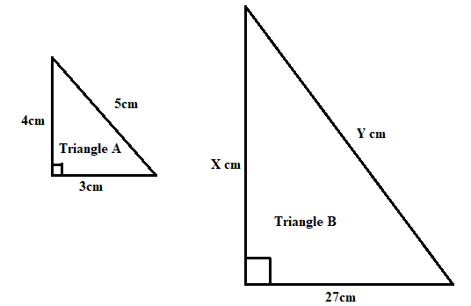

Triangle A and Triangle B are similar in the sense that they are both right-angle.
The similarity of triangles gives rise to trigonometry. Using knowledge of similarity, the other two measurements of Triangle B can be deduced by comparing the ratios of corresponding sides as follows.

$\frac{X}{4}=\frac{27}{3}$
$X=\frac{4×27}{3}=36cm$

Also,

$\frac{Y}{5}=\frac{27}{3}$
$Y=\frac{5×27}{3}=45cm$

Therefore, it has been possible to determine the missing sides of the big triangle A given that at least one is known with accuracy as 27cm, the smaller triangle A has small measurements that can be accurately determined.
- How could we understand that the right triangles of trigonometry with a hypotenuse of measure 1 represent all possible right triangles?
The idea that right triangles with a hypotenuse of measure 1 represent all possible right triangles is closely related to the concept of trigonometric ratios and the unit circle. Let me explain how this works:
Unit Circle: Imagine a unit circle, which is a circle with a radius of 1 unit. The center of the circle is at the origin (0, 0) on a Cartesian coordinate system. This unit circle is often used in trigonometry.
Right Triangles: Now, consider any right triangle. In trigonometry, we often focus on the angles and sides of right triangles. The two legs of a right triangle are perpendicular to each other, and the hypotenuse is the side opposite the right angle.
Similarity: When you scale a right triangle so that its hypotenuse becomes 1 (which is essentially dividing all sides of the triangle by the length of the hypotenuse), you get a similar triangle that is proportional to the original right triangle. This means the ratios of the side lengths of the scaled triangle are the same as the ratios of the side lengths of the original triangle.
Trigonometric Ratios: In trigonometry, we use three primary trigonometric ratios: sine (sin), cosine (cos), and tangent (tan). These ratios are defined as the relationships between the sides of a right triangle. For example:
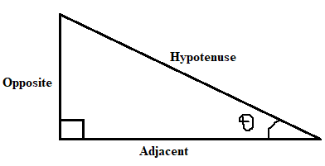
Normalization: By scaling down all right triangles to have a hypotenuse of 1, the hypotenuse becomes the radius of the unit circle. This simplifies the trigonometric ratios:

$$sinθ=\frac{Opposite}{Hypotenuse}$$
$$cosθ=\frac{Adjacent}{Hypotenuse}$$
$$tanθ=\frac{Opposite}{Adjacent}$$

Representation of All Possible Right Triangles: Since all right triangles can be scaled down or up to have a hypotenuse of 1, the unit circle essentially represents all possible right triangles. You can think of the unit circle as a universal reference for trigonometric values. The angles on the unit circle correspond to the angles in right triangles.
- Ultimately, the similarity of triangles is the basis for proportions between sides of two triangles, and these proportions allow for the calculations of which we are speaking here. The similarity of triangles is the foundation of trigonometry.
The concept of similarity in triangles is indeed the foundation of trigonometry. Similar triangles are triangles that have the same shape but may be of different sizes. The properties of similar triangles and the ratios of their corresponding sides are fundamental to trigonometric calculations. In trigonometry, the ratios of the sides of right triangles, such as sine, cosine, and tangent, are defined based on the similarity of triangles. By comparing corresponding sides of similar triangles, we establish these ratios, which are then used to calculate various quantities in geometry and trigonometry. Finally, the unit circle, as mentioned earlier, simplifies these trigonometric ratios and calculations by ensuring that all right triangles can be scaled to have a hypotenuse of 1. This uniformity allows for a standard reference point for trigonometric values and facilitates a deeper understanding of angles and their relationships. Therefore, it is absolutely correct in highlighting the importance of triangle similarity as the foundational concept that underpins trigonometry and enables the calculation of angles, side lengths, and various geometric relationships. It's a key concept in mathematics and science, particularly in fields where angles and proportions play a crucial role.

